 | 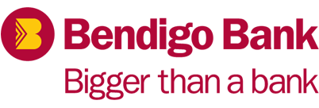 | 

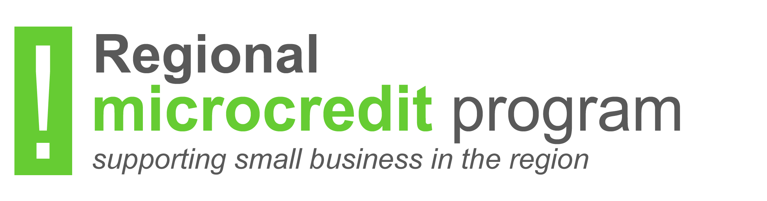

expression of interest form

REGIONAL MICROCREDIT LOAN PROGRAM
Supported by the Bega Valley Shire Council and Bendigo Bank

Delivered by: Lighthouse Business Innovation Centre Limited (Lighthouse)
6/65 Tennant Street, Fyshwick, ACT 2609
PO Box 1228, Fyshwick ACT 2609
Ph: +61 2 6163 8300
Fax: +61 2 6163 8399
REGIONAL MICROCREDIT EXPRESSION OF INTEREST (EOI) FORM
The Bega Valley Shire Council adopted an Economic Development Strategy (EDS) in mid-2015. The EDS identifies objectives and strategies to achieve them over the period 2016 to 2021. The EDS recognises Council has a role supporting the economy at the local or town and village levels and also at a regional or Shire wide level. The Regional Microcredit pilot is one tool being used to achieve these objectives.
The program provides a limited number of no interest, fee-free loans for eligible applicants who wish to start or expand an existing business. The program will also provide loan recipients with business skills development, individual mentoring, peer support and access to networking events.
The loans target younger entrepreneurs from the ages of 18 through to 40. Other entrepreneurs are encouraged to apply.
Loans are available on a competitive basis.
Eligibility to time limited, no interest, fee-free loans (up to $3,000) are now available to Bega based entrepreneurs. Can be any of the following:
You:
- Hold a Pensioner Concession Card and/or a Health Card (for a minimum of 6 months) or their equivalent;
- Do not qualify for the above but are unable to apply for a bank business loan because of illness, unemployment, financial stress or other reasonable cause;
- Receive a Centrelink payment;
- Are in a household whose total income is less than $65,000 per annum.
There is a multistage application process for loans under this program:
- View the Regional Microcredit orientation session for an overview of the program and the applicants responsibilities (www.regionalmicrocredit.com.au)
- Complete and submit this Expression of Interest (EOI) form by emailing to:
enquiries@regionalmicrocredit.com.au
- Application forms will be sent to those applicants who have been accepted to progress to full application.
- Short listed applicants will be required to ‘pitch’ their idea to a selection panel.
- All applicants will be provided with feedback and if unsuccessful be referred to other assistance programs where possible.

FURTHER INFORMATION
For further information or assistance contact Lighthouse:
Phone: 02 6163 8300
Email: enquiries@regionalmicrocredit.com.au

APPLICANT DETAILS:
Title (Mr, Ms, Mrs, etc)
Given Name/s
Family Name/Surname
Contact telephone Number
Contact Email address
Street Address
Business Structure (for existing businesses) | Sole proprietor Partnership Company
Business Name and ABN/ACN
(for existing businesses)
Date Registered (if applicable):
How long have you been actively trading?
Business Website (if applicable):
Are you registered for GST? | Yes No

LOAN DETAILS:
Amount Sought  Up to $3,000 (interest free) | $________________
Total cost of your idea or business development. | $________________
If loan will not cover entire cost of idea or business development, how will you fund the rest of the project?

ELIGIBILITY CHECKLIST:
Check box if YES
  - Do you hold one or receive one or more of the following issued under the A New Tax System (Family Assistance) Act 1999 (Cth) or Veterans Entitlement Act 1986 (Cth):
- a Pensioner Concession Card or its equivalent; and/or
- A Health Card (for a period of at least 6 months) or its equivalent; or
- receive a Centrelink payment.
  - If you do not qualify for any of the above, are you due to illness, unemployment, financial stress or other reasonable cause unable to apply for a bank business loan.
  - If you comply with either or both dot points above, your combined family income (including de facto) is less than:
- $65,000 if applying for up to $3,000 no interest loan; or
  - (You will be required to provide proof of income)
  - You have been a resident of the Bega Valley Shire for the past six months (proof of residency required).
  - You can commit to the terms of the loan agreement.
- You are a permanent Australian resident.
- You can clearly describe the business opportunity/existing business that requires funding.
- You undertake to work with a Lighthouse client manager to identify any skills or training development needs you may require.
- The business opportunity presents the potential to provide favourable economic outcomes to the Bega Valley Shire economy.
- You have participated in (either in person or online) the Regional Microcredit Orientation session.

Please note – If you cannot tick ALL of the boxes above, you may not be eligible to apply for this loan and your application will not progress further. If unsure, please contact the Lighthouse Client Manager.

PROJECT DESCRIPTION:
Describe your business idea. (Please give a brief description of your business idea and what problem you are solving for customers and why they will buy from you.)

Describe your product or service features. (Give a brief description of the products or services you will offer. What features will give you the edge in the marketplace?)

Describe your market(s). (Who are your customers? Will it be easy for them to see the benefits of your products or services? How do they compare to competitors in the marketplace?)

What have you done to validate your idea? (Have you done any kind of research to prove your idea will work? Do you have customers?)

How will you use the loan money?

How will you fund any activities not covered by the loan money?
(You will be required to submit a personal budget with proof of income if asked to submit a full application. If you are an existing business you will need to provide proof of income and a cash flow budget).

Have you participated in/or viewed the Regional Microcredit Orientation Session?
(Sign in will be required as proof)
Yes No
Have you had contact with a Lighthouse Client Manager?
Yes No

SUBMITTING YOUR EXPRESSION OF INTEREST:
Please email completed EOI to enquiries@regionalmicrocredit.com.au
Once you have submitted your EOI a Lighthouse client manager will contact on behalf of BVSC you to arrange a time to discuss your proposal and assess if it is suitable for consideration under the Regional Microcredit Loan program. Should your idea/business concept be determined suitable for consideration under this program, you will be invited to submit a written formal application.
NOTE:
This form is provided as a loan application document and no undertaking or representation is made that an applicant will be granted a loan by answering the questions or following the procedures herein. Applicants should ensure they seek assistance if required to complete the form. Lighthouse Client Managers are available to assist you with your application.
The receipt of this application by Lighthouse does not constitute any entitlement to a loan until such time as the Loan Agreement is signed by the Applicant and the appointed representative of Lighthouse.
PRIVACY POLICY
The personal information you provide for the purpose of your application is protected by the Privacy Act 1988 (Cth). The provision of your personal information is voluntary, but is necessary to determine your suitability to participate in the Regional Microcredit Program. The information in this application form may be discussed with other government entities to assist with assessing your suitability for this or other related programs. If you would like to access your personal information, please call a Lighthouse Client Manager.
CERTIFICATION

You agree that by submitting the application you are indicating your understanding and acceptance of the following terms and conditions:
I have read the Guidelines and completed the Eligibility Checklist, and to the best of my knowledge, this application is eligible under those criteria.
I understand and accept that Lighthouse on behalf of BVSC may be required to liaise with other organisations, including Commonwealth Government Departments, in relation to applications for assistance. I agree to the release of information contained in the application, including personal information by officers of Lighthouse to these organisations for the purpose of Lighthouse assessing the application.
I understand and accept that should the application be successful, a formal agreement will need to be executed with Lighthouse prior to release of the funds.
I understand and accept that if the applicant is offered a loan, the project title, project outcomes and loan support offered may be published by BVSC and/or Lighthouse in material for the promotion of its programs or in meeting requirements of the BVSC.
The information provided in this application, including attachments, is true and correct to the best of my knowledge.
I understand this form becomes the property of BVSC once submitted.

Name:

Signature:

Date:

/ /

